Baker Towers – Wisenet Camera Access Instructions

For Baker Towers Unit Owners Only
Camera access is provided for building security awareness. Access is restricted to unit owners and must not be shared with tenants or third parties. Misuse or unauthorized changes may result in access being revoked.
Purpose
This guide explains how Baker Towers owners can access the building’s security cameras using the Wisenet Mobile App.

Step-by-Step Instructions
Step One: Download the Wisenet Mobile App on your phone.

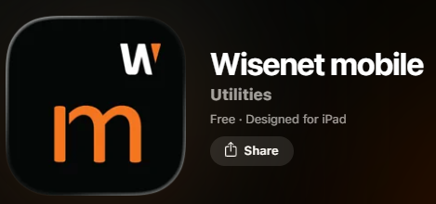
Apple App Store Or Google Play Store


Step Two: When prompted, allow notifications and camera access. Camera access is required to scan the QR code. It will open your phone camera immediately.
Step Three: Scan this QR code:
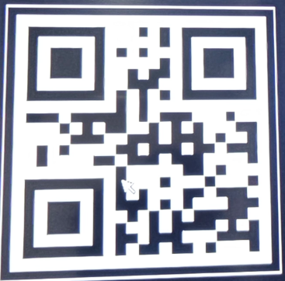

Step Four: Tap the link displayed below the QR code. This will automatically populate the Product ID (6KMJC6NY).

Step Five: Type in the following information:
User ID: admin
Password: Ad$902211400
Once logged in, the app will display short tutorial prompts. Once loaded, you will see multiple camera tiles. Tap any tile to enlarge the live feed.

Responsible Use & Privacy Notice
- Camera access is provided solely for building security awareness.
- Owners are expected to use this system responsibly and respectfully.
- Any misuse, unauthorized sharing, or alteration of settings may result in access being revoked and further action as deemed appropriate by the Association.
- Any attempt to use the system to harass, intimidate, or invade the privacy of others is not permitted.
- Camera access is for OWNERS only and may not be shared.
- This is a shared building login.
- Do NOT change the username or password. Any changes will disable access for all owners.

Troubleshooting
- If cameras do not load, fully close and reopen the app.
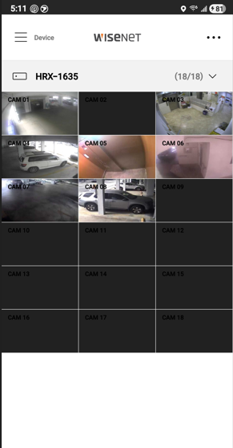
- Confirm camera permissions are enabled in your phone settings.
- Ensure you tapped each camera tile at least once to initialize the feed.

